EXPERIMENT – 9

Title
AI-Based Traffic Prediction Using Number of Vehicles in google collab

Aim
To design and simulate an AI-based traffic prediction system that predicts the number of vehicles at different time intervals and evaluates the prediction accuracy using Python in Google Colab.

Apparatus / Software Required
- Google Colab
- Python 3
- Matplotlib library

Objectives
To analyze the number of vehicles at different time intervals, compare actual and predicted traffic values, calculate the prediction error, determine the average prediction error, and visualize the traffic prediction results using graphs.

Theory
AI-based traffic prediction systems use historical and real-time traffic information to estimate future traffic conditions. Traffic volume can vary depending on the time of day, road conditions, and other factors.
In this experiment, the number of vehicles is used as the main traffic parameter. Actual vehicle counts and predicted vehicle counts are provided for different time intervals from 8 AM to 2 PM.
The system compares the actual and predicted values and calculates the prediction error using:
Prediction Error = |Actual Value − Predicted Value|
The average prediction error is calculated as:
Average Error = Sum of Prediction Errors / Number of Time Intervals
Two graphs are generated:
- Actual vs Predicted Number of Vehicles
- Traffic Prediction Error
These graphs help evaluate how closely the predicted traffic values match the actual values.

Algorithm
- Start the program.
- Import the Matplotlib library.
- Define the time intervals from 8 AM to 2 PM.
- Store the actual number of vehicles for each time interval.
- Store the predicted number of vehicles.
- Compare the actual and predicted values.
- Calculate the absolute prediction error for each time interval.
- Calculate the average prediction error.
- Display the actual and predicted traffic values.
- Display the prediction performance.
- Plot the actual and predicted number of vehicles.
- Plot the prediction error for each time interval.
- Display the final average prediction error.
- Stop the program.

Procedure
- Open Google Colab and create a new notebook.
- Import the matplotlib.pyplot library.
- Define the time intervals.
- Enter the actual number of vehicles.
- Enter the predicted number of vehicles.
- Calculate the prediction error for each time interval.
- Calculate the average prediction error.
- Display the traffic prediction data.
- Generate the Actual vs Predicted graph.
- Generate the Prediction Error graph.
- Observe the graphs and average prediction error.
- Display the final result.

Sample Data
Time | Actual Vehicles | Predicted Vehicles | Error
8 AM | 45 | 47 | 2
9 AM | 52 | 50 | 2
10 AM | 60 | 62 | 2
11 AM | 68 | 65 | 3
12 PM | 75 | 73 | 2
1 PM | 82 | 85 | 3
2 PM | 90 | 88 | 2

Sample Calculation
For 8 AM:
Error = |Actual − Predicted|
= |45 − 47|
= 2 vehicles
The errors for all time intervals are:
2, 2, 2, 3, 2, 3, 2
Therefore,
Average Prediction Error = (2 + 2 + 2 + 3 + 2 + 3 + 2) / 7
= 16 / 7
= 2.29 vehicles
Phyton code:
# ============================================
# AI-Based Traffic Prediction
# Different Parameter: Number of Vehicles
# Google Colab
# ============================================

import matplotlib.pyplot as plt

print("=" * 50)
print(" AI-BASED TRAFFIC PREDICTION")
print("=" * 50)

# Time intervals
time = ["8 AM", "9 AM", "10 AM", "11 AM", "12 PM", "1 PM", "2 PM"]

# Actual number of vehicles
actual = [45, 52, 60, 68, 75, 82, 90]

# Predicted number of vehicles
predicted = [47, 50, 62, 65, 73, 85, 88]

# --------------------------------------------
# Calculate Prediction Error
# --------------------------------------------

errors = []

for i in range(len(actual)):
errors.append(abs(actual[i] - predicted[i]))

average_error = sum(errors) / len(errors)

# --------------------------------------------
# Display Values
# --------------------------------------------

print("\nTraffic Prediction Data")
print("-" * 50)

for i in range(len(time)):
print(
time[i],
": Actual =", actual[i],
"vehicles, Predicted =", predicted[i],
"vehicles"
)

# --------------------------------------------
# Performance
# --------------------------------------------

print("\nPrediction Performance")
print("-" * 50)

print(
"Average Prediction Error =",
round(average_error, 2),
"vehicles"
)

# --------------------------------------------
# Graph 1: Actual vs Predicted
# --------------------------------------------

plt.figure(figsize=(8, 4))

plt.plot(
time,
actual,
marker="o",
label="Actual Vehicles"
)

plt.plot(
time,
predicted,
marker="s",
label="Predicted Vehicles"
)

plt.title("Actual vs Predicted Number of Vehicles")
plt.xlabel("Time")
plt.ylabel("Number of Vehicles")
plt.legend()
plt.grid(True)

plt.show()

# --------------------------------------------
# Graph 2: Prediction Error
# --------------------------------------------

plt.figure(figsize=(8, 4))

plt.bar(
time,
errors
)

plt.title("Traffic Prediction Error")
plt.xlabel("Time")
plt.ylabel("Error (Vehicles)")
plt.grid(axis="y")

plt.show()

# --------------------------------------------
# Final Result
# --------------------------------------------

print("\n" + "=" * 50)
print("Traffic Prediction Analysis Completed")
print("Average Error =", round(average_error, 2), "vehicles")
print("=" * 50)

Expected Output

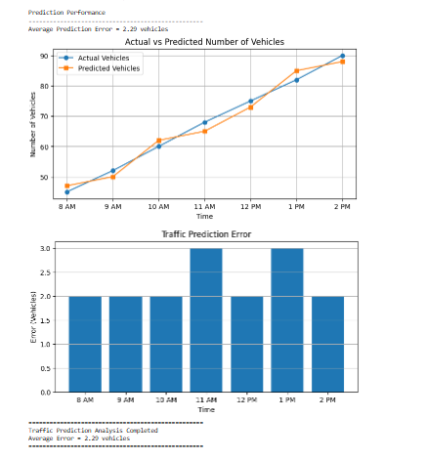

Result
The AI-Based Traffic Prediction System was successfully simulated using Python in Google Colab. The actual and predicted number of vehicles were compared, prediction errors were calculated, and the average prediction error was found to be 2.29 vehicles. The results were successfully visualized using graphs.

